1. 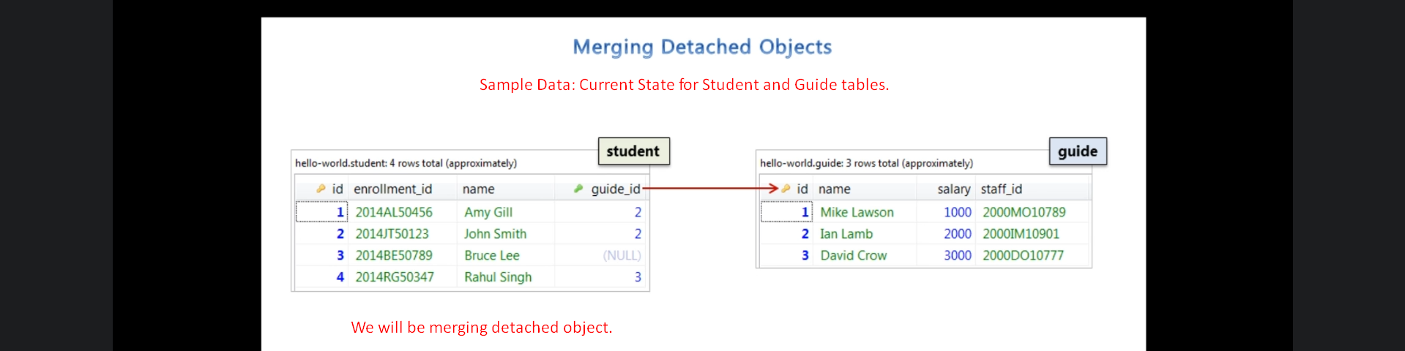
2. 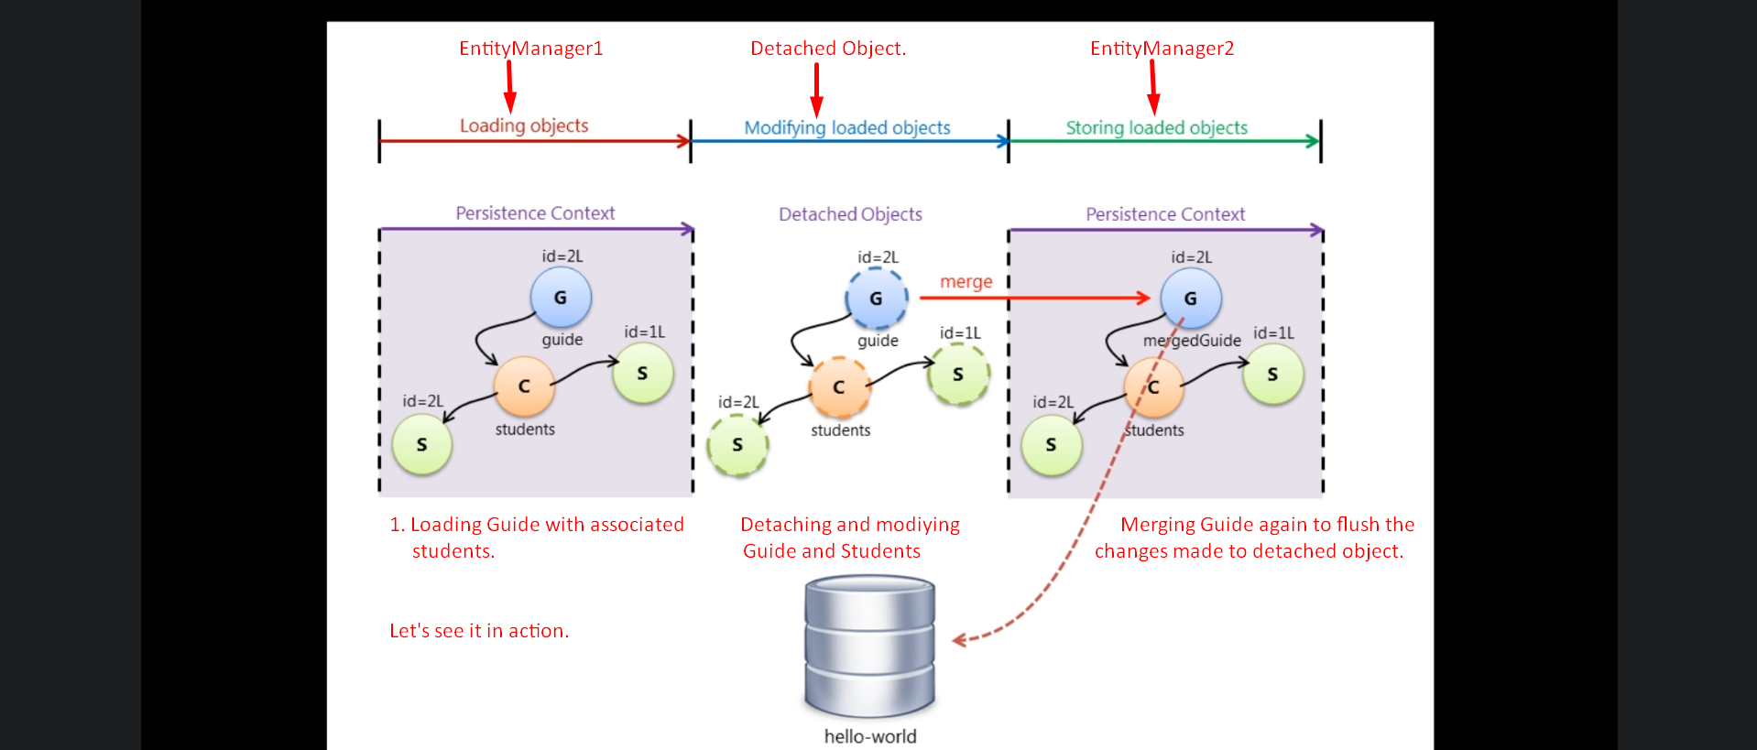
3. 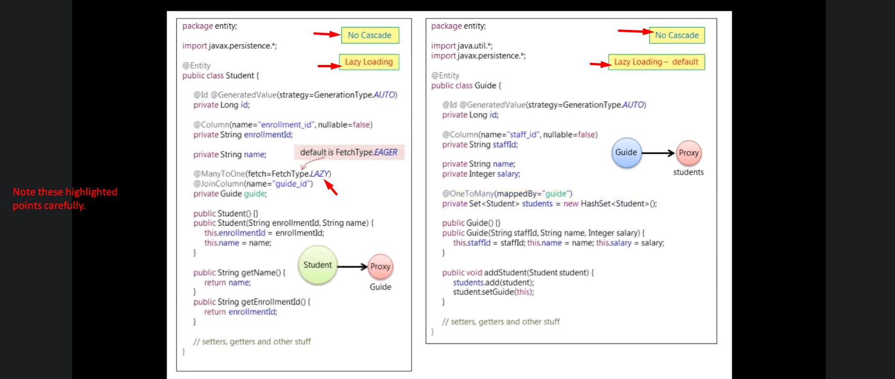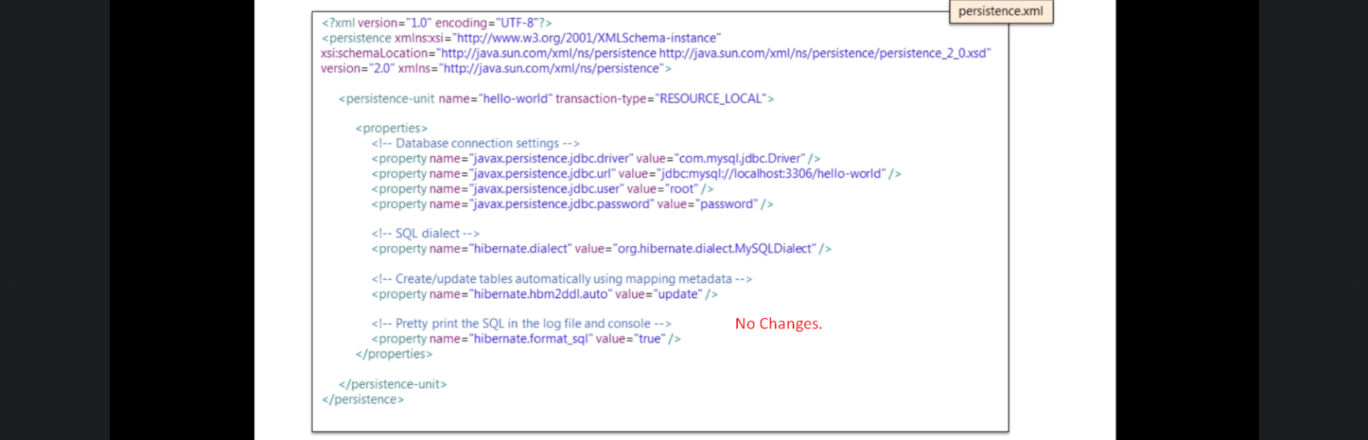
4. For each line we will take a snapshot to see the transition/changes as per code.
5. 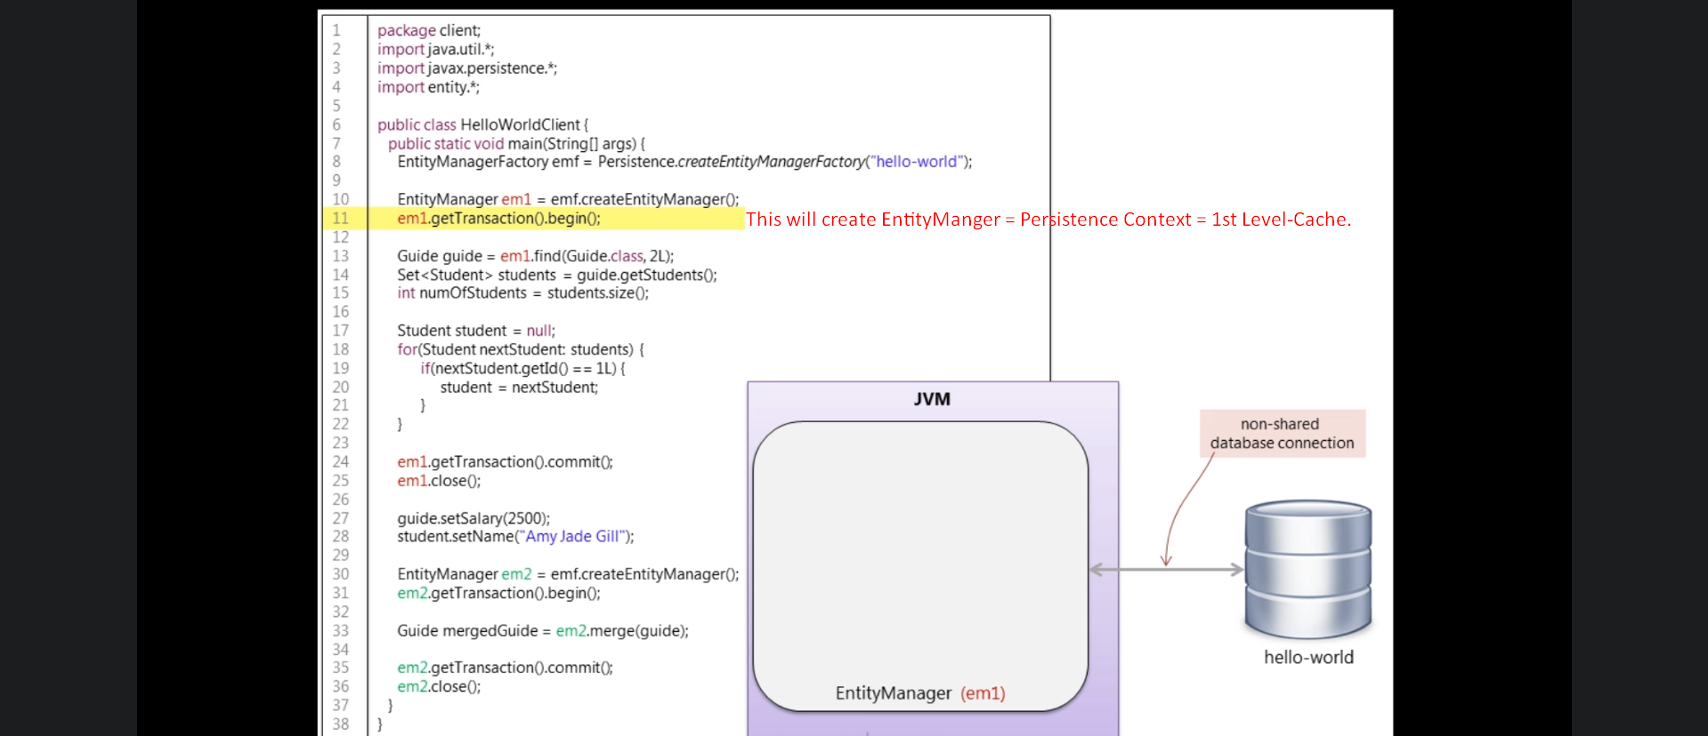
6. 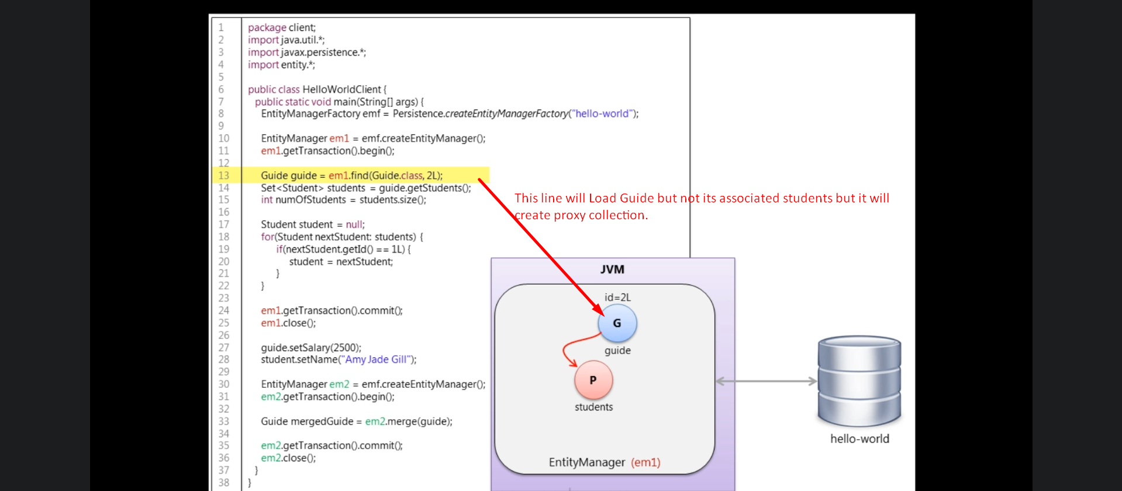
7. 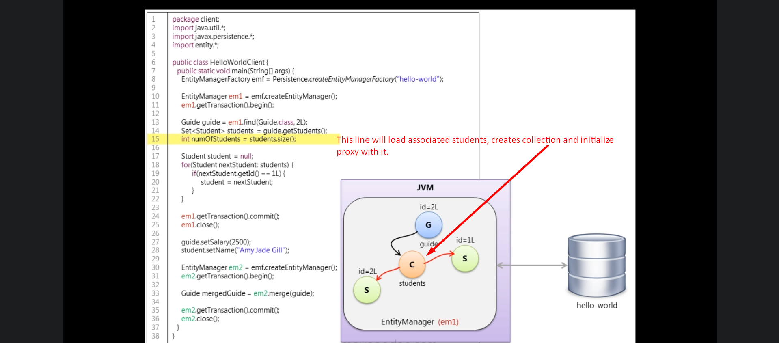
8. 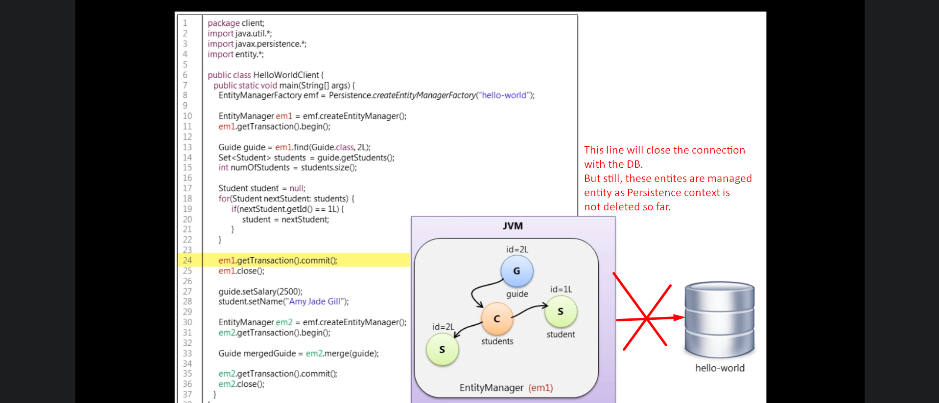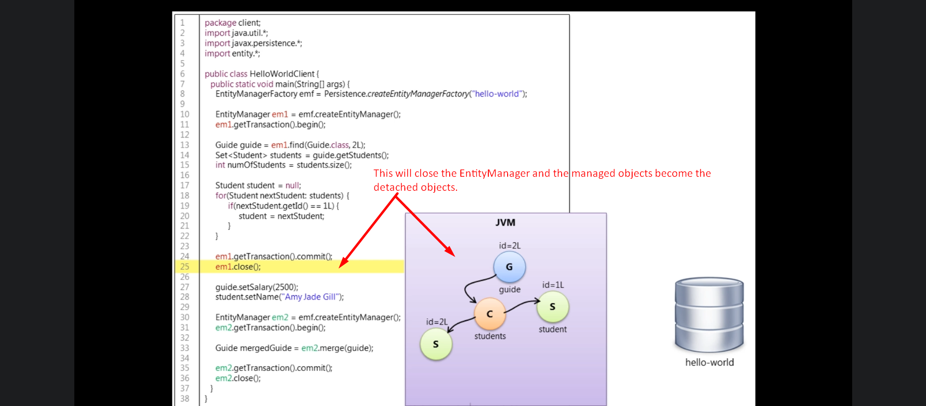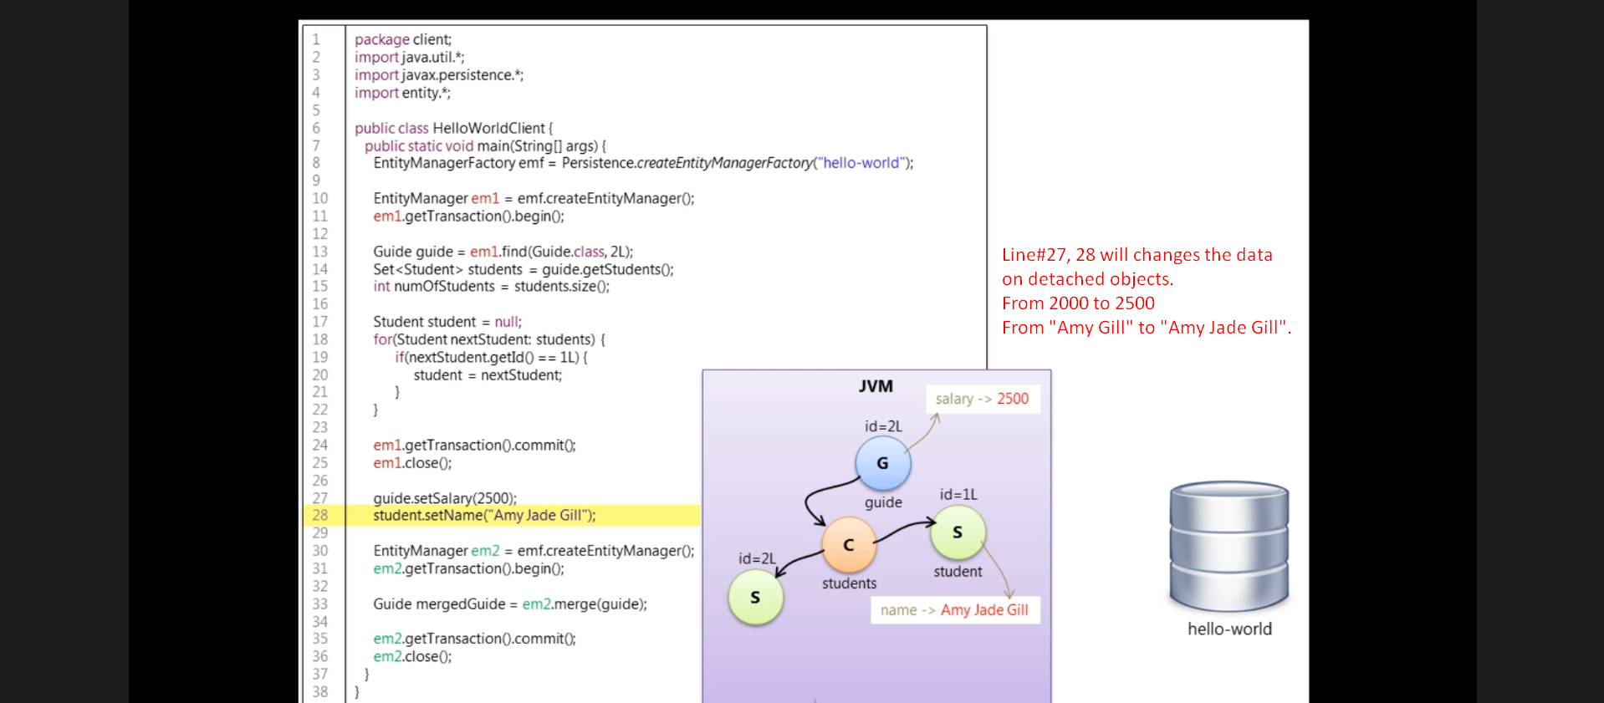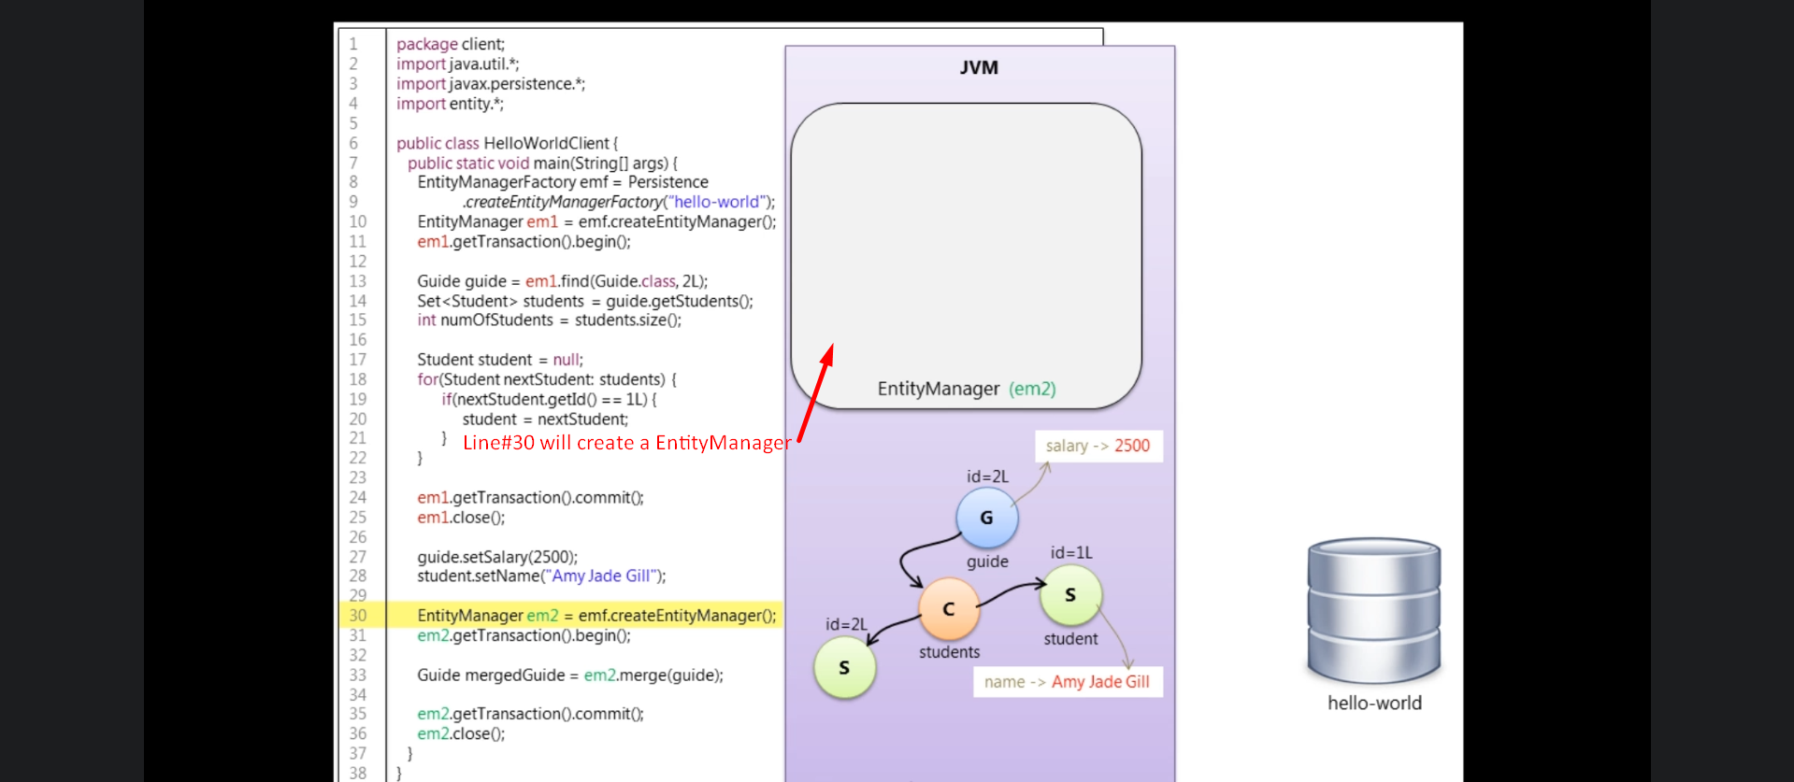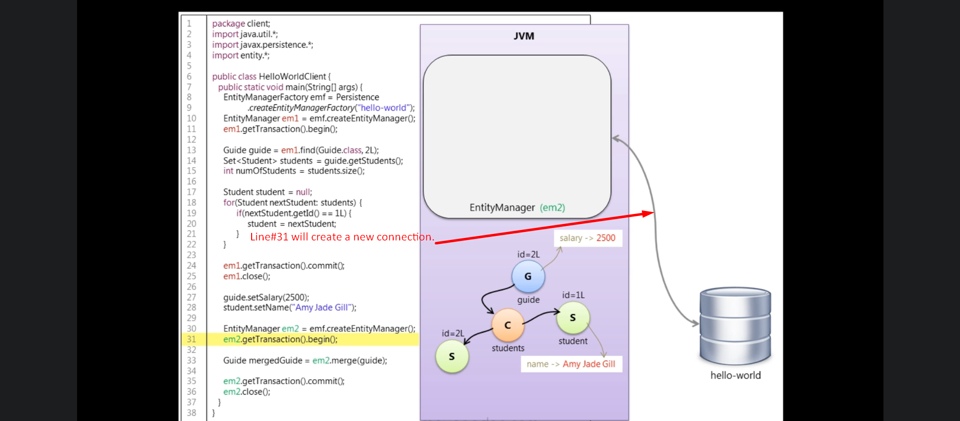
9. 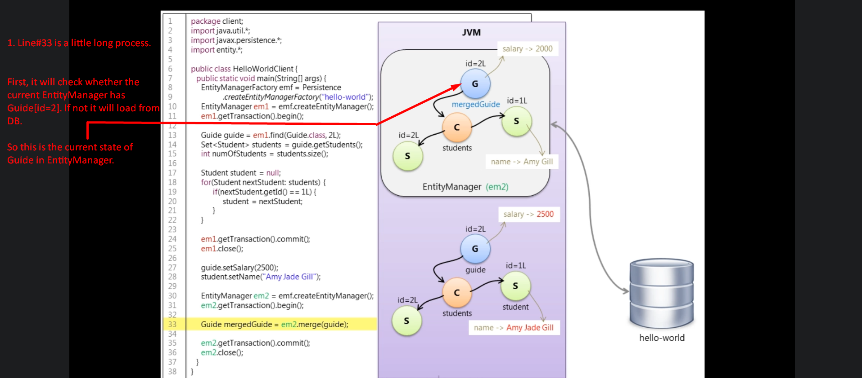
10. 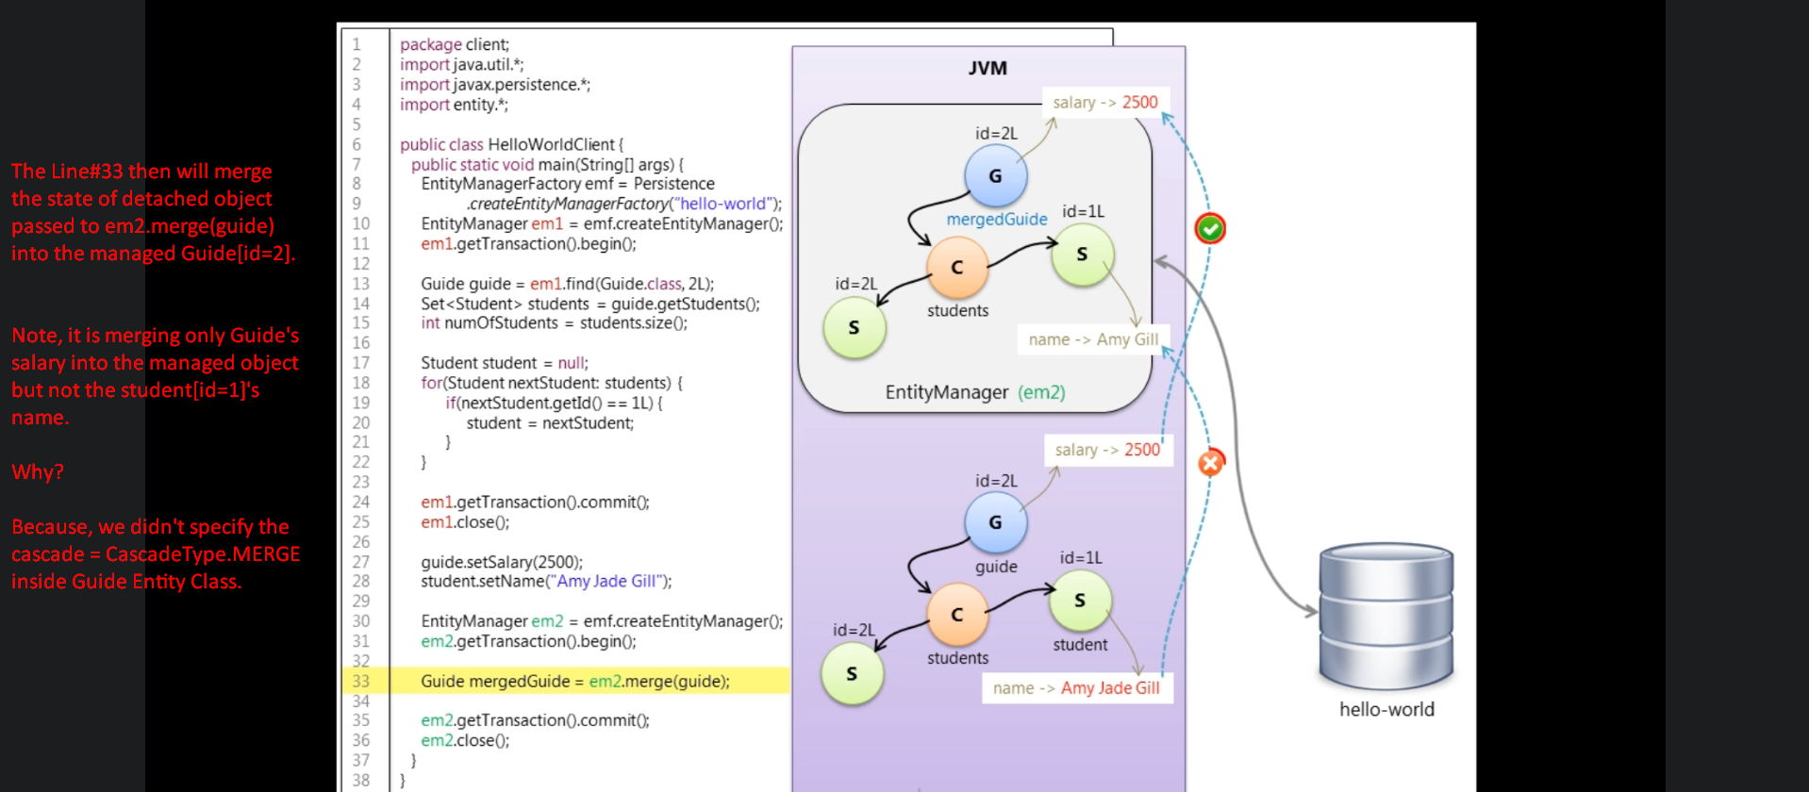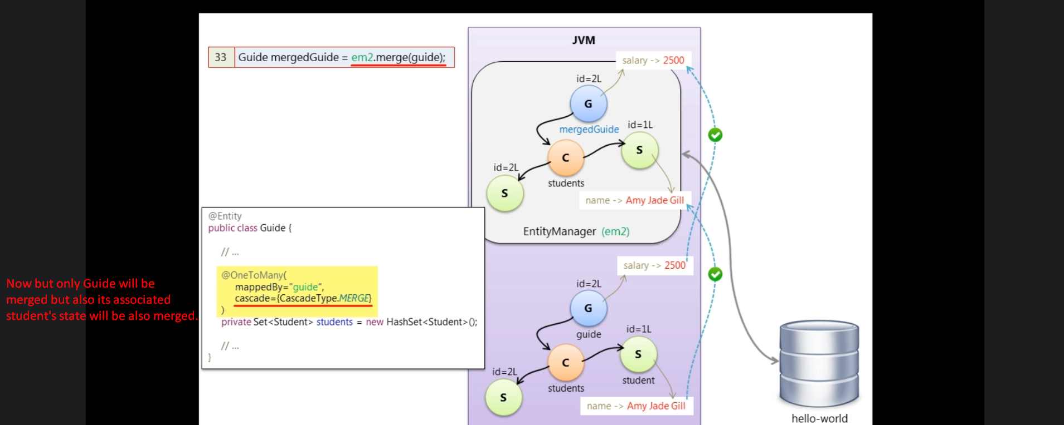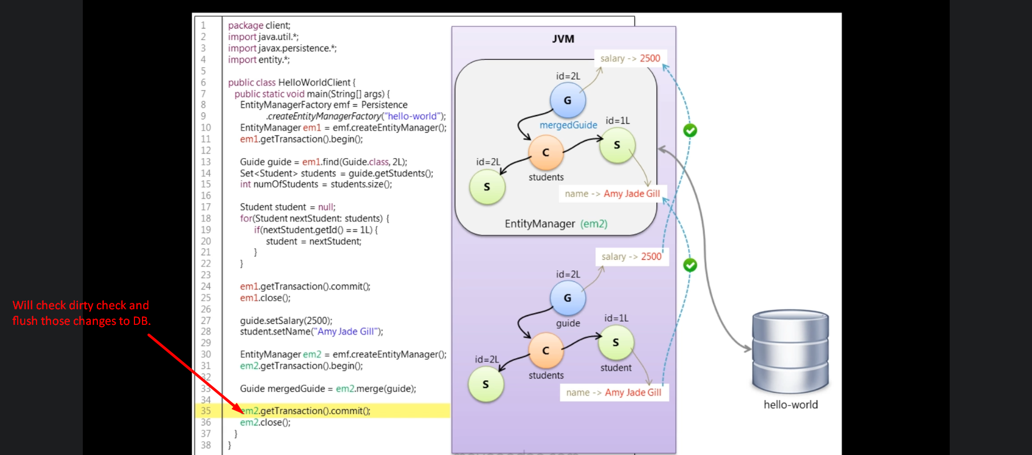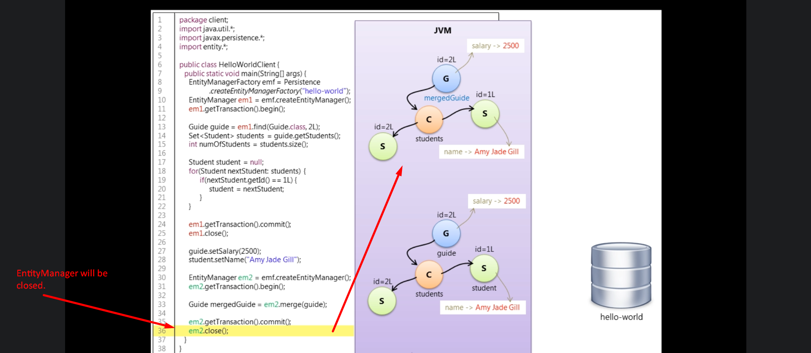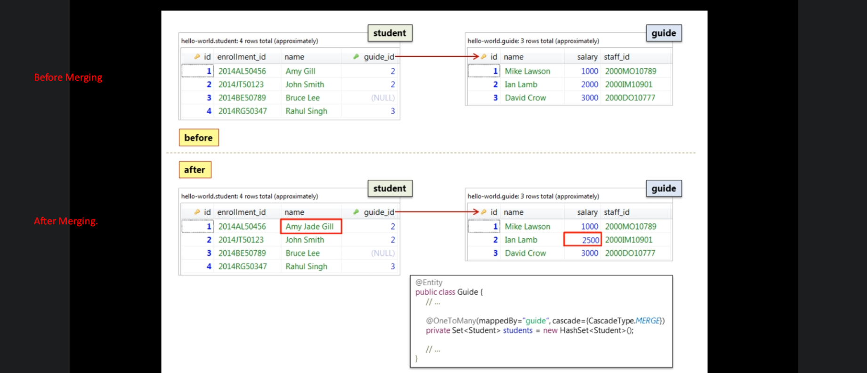
11. **Question**: Why do we need to detach an object to do modifications? Can’t we do all the modifications while it is associated with Persistence Context?
12. **Answer**:
    1. In multi-user application, you don’t usually maintain a database transaction across a user interaction with an app, just like the interaction we’re trying to simulate in the example here where a user is loading object, modifying them and saving them back to the DB. Users take a long time thinking about the modifications. So for scalability reasons, you must keep the database transactions short and release database resources as soon as possible.  
       The answer is that you could do these modifications while having them associated with the persistence but the underlying JDBC connection needs to remain disconnected while the objects are being modified by the user and we do that by extending the persistence context. So we will have one persistence context but multiple transactions across a user interaction and the modification of each act will be done while there is no underlying JDBC connection and there will be no need of merging this time as the objects are already associated with persistence context and we don’t have any detached object to merge.  
       Let’s have a quick look at the code. 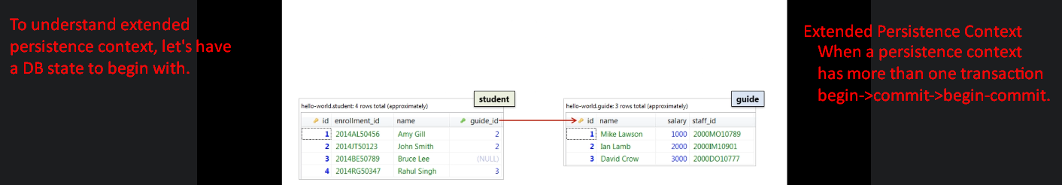
    2. 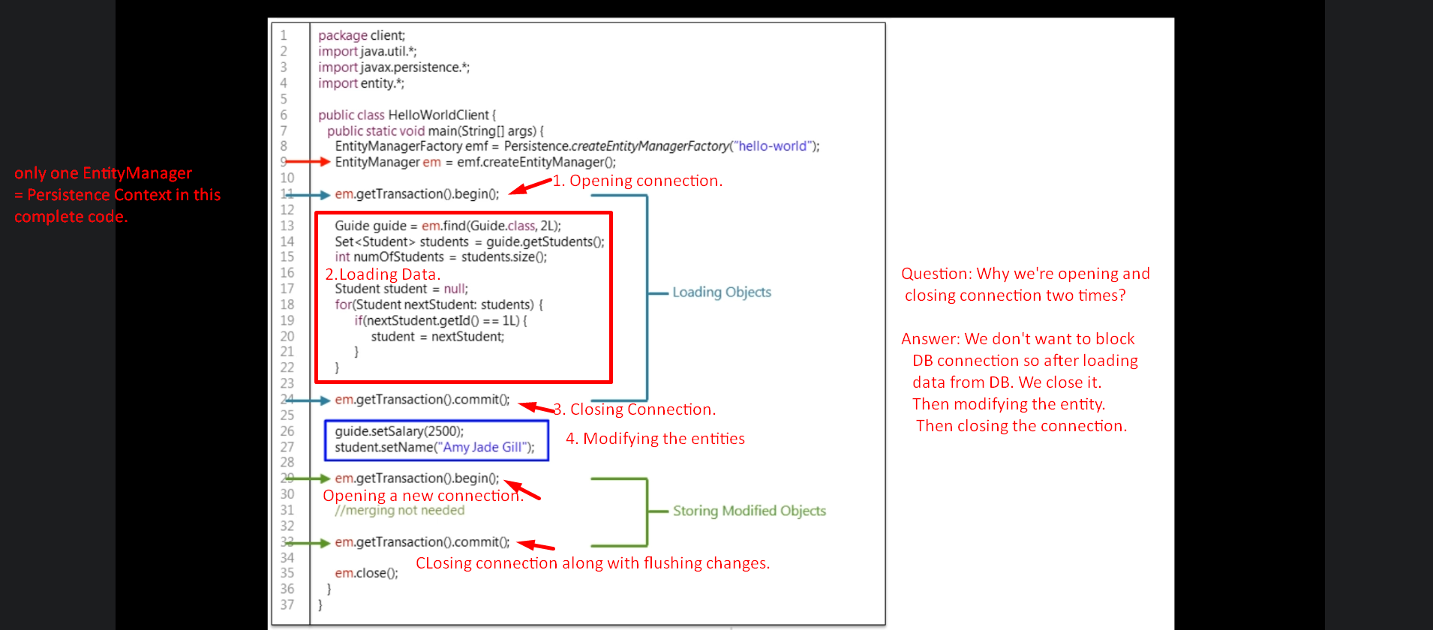
    3. 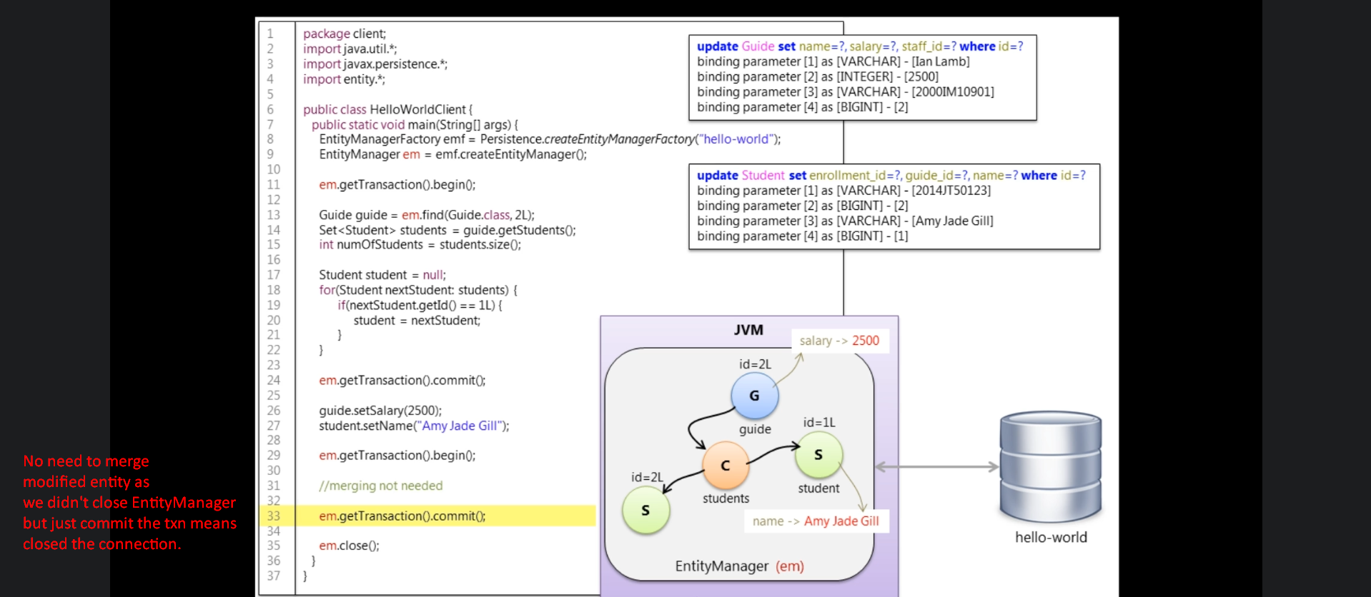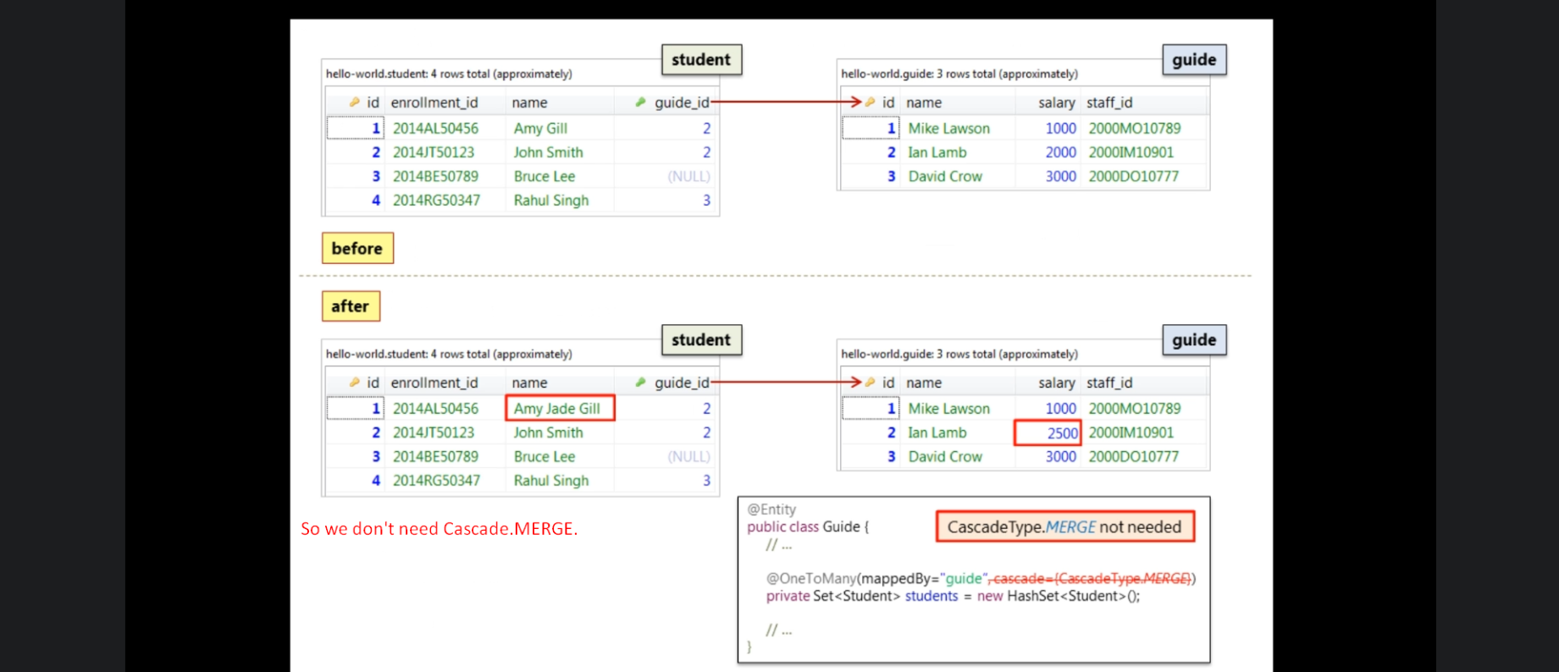
13. So, till now we saw two implementations for loading, modifying, storing objects.  
    